Day 2 Agenda

1. Git
2. BitBucket (Github)
3. JIRA
4. Jenkins

Git –

What – Opensource Distributed Version Control System (Linus Torvalds)

Why – For Maintaining, tracking changes to all the source code.

How -

Version Control System – SVN, Perforce, Clearcase

Repository – Local Repo, Remote Repo.

Download and install Git latest version from the official site

<https://git-scm.com/download/win>

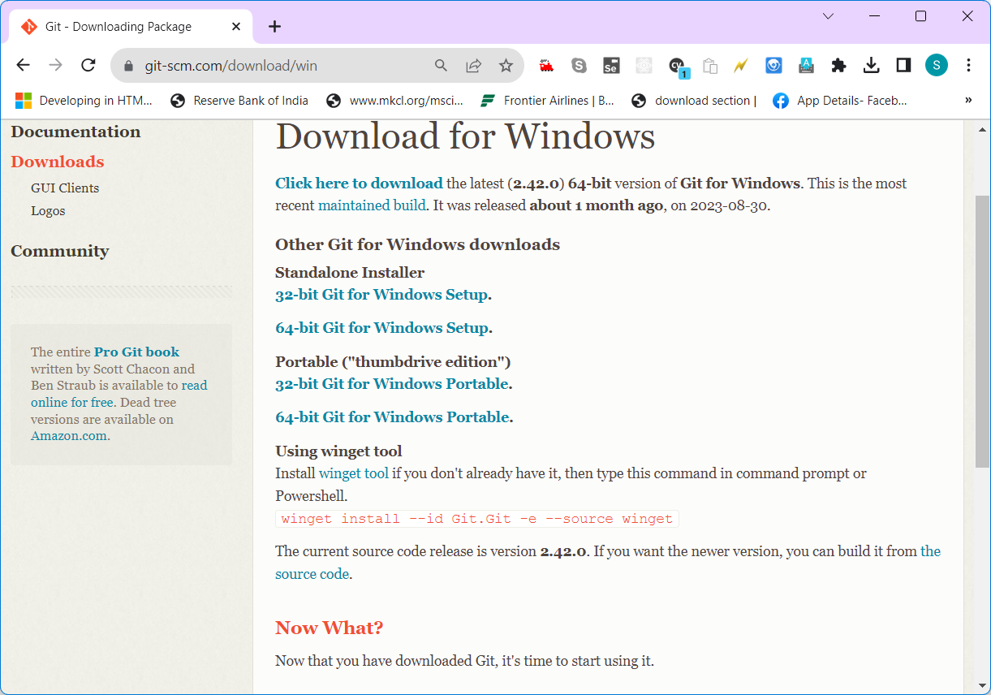



Download and Install Eclipse IDE from official site

<https://www.eclipse.org/downloads/packages/>

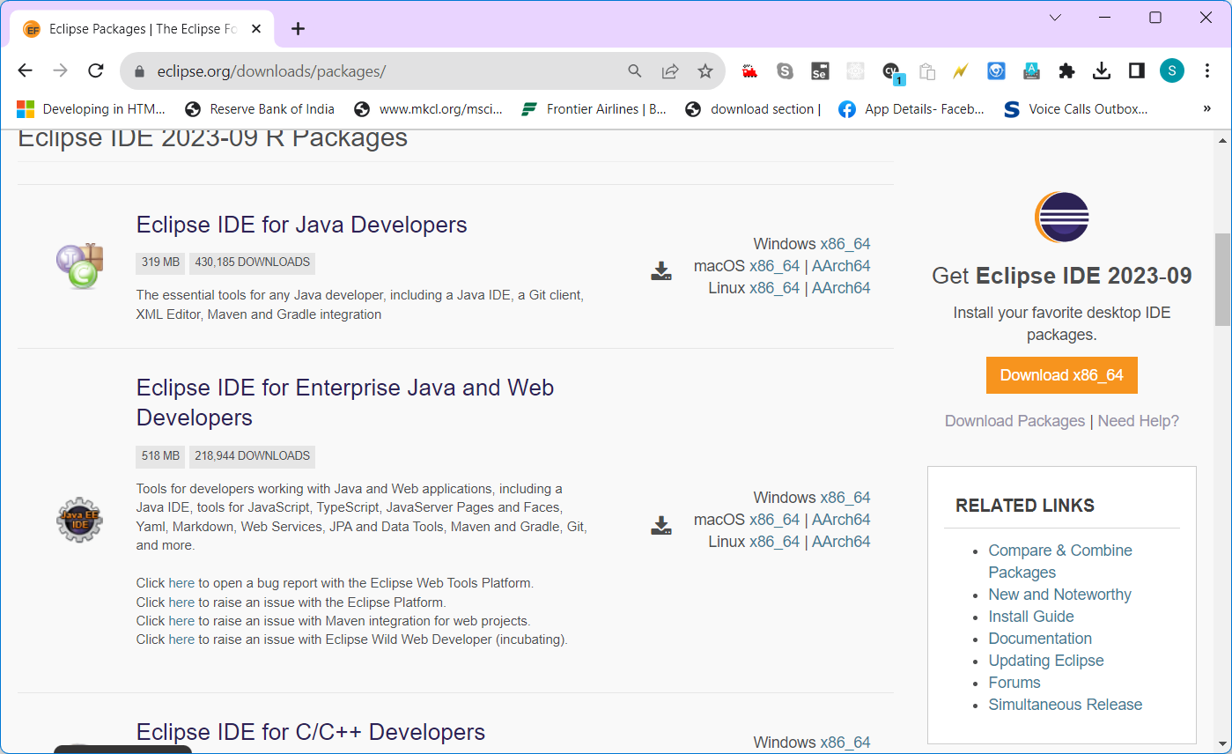



Download and Install IntelliJ IDEA from official Site

<https://www.jetbrains.com/idea/download/?section=windows>

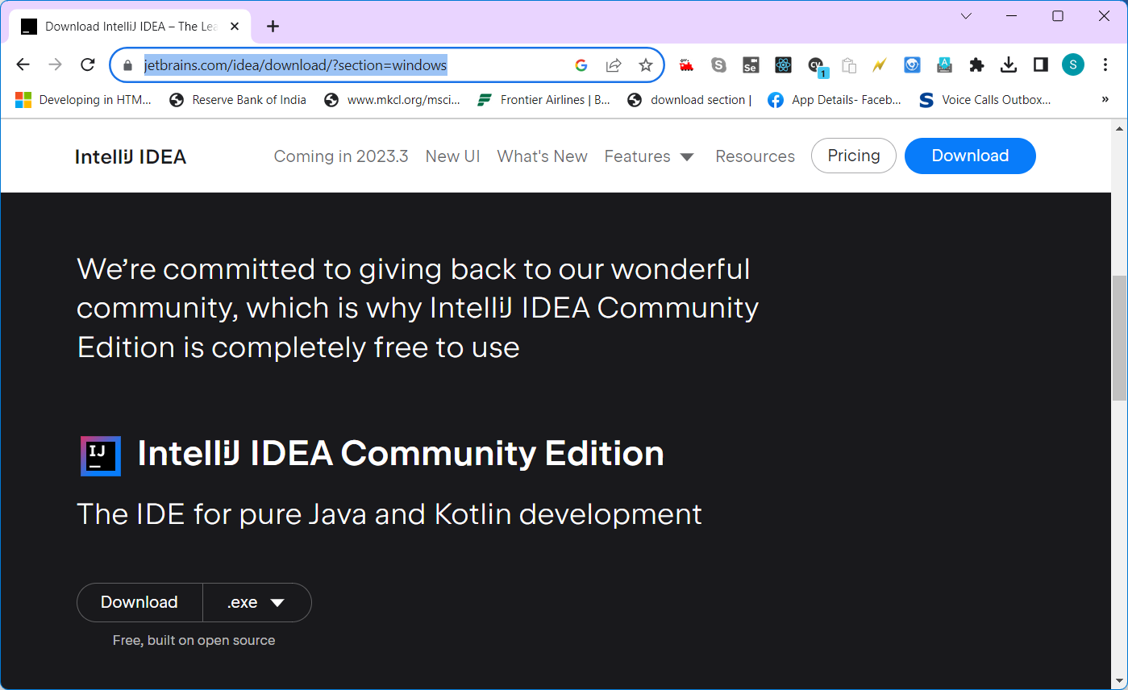

Git –

Git Bash = Git CLI (Command Line Interface)

GUI – Graphical User Interface

CUI – Character User Interface

Local Repository – Folder in the File system (git init)

Git init

Git add .

Git status

Git commit -m “first commit”

Git log

Git config -g user.name “sivakumar os”

Git config -g user.email [syskantechnosoft@gmail.com](mailto:syskantechnosoft@gmail.com)

git remote add origin https://github.com/syskantechnosoft/sapient2023.git

git push -u origin master

Jenkins

CI - Continuous Integration

CD – Continuous Deployment/delivery

DevOps – Development + Operations ( Running the code in production Environment – Config changes)

Download Jenkins from official site

<https://www.jenkins.io/download/>

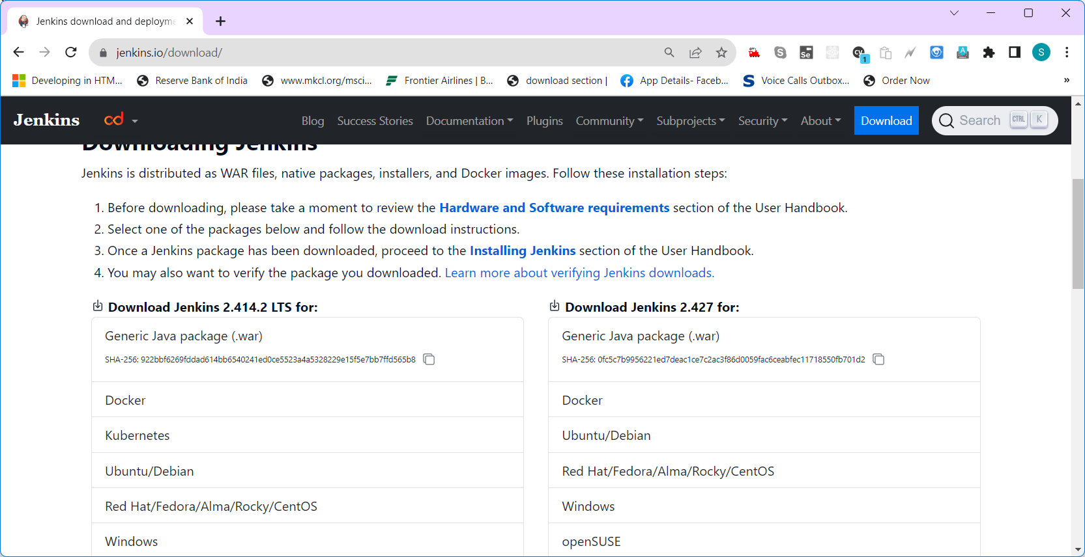



Jenkins Automation Server

Web Application (Client – Server Application) Client- Server Tech [ Request/Response]

Creating a Pipeline

CI/CD Tools

TDD – Test Driven Development (

BDD – Behaviour Driven Development

Cloud Types

PaaS – Platform as a Service

IaaS – Infrastructure as a Service ( Providing hardwares alone) – EC2

SaaS – Software as a Service